Preparation Sheet January 2019

Theme for the year: Wisdom Hidden
In Plain Sight

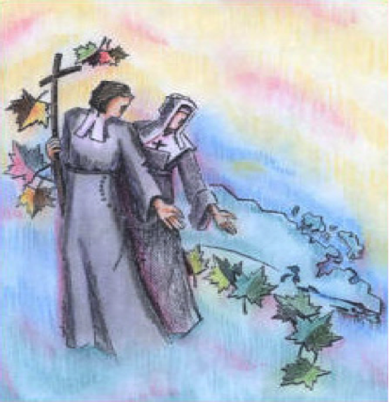
Wisdom 6:12-14 (New Jerusalem Bible):
Wisdom is brilliant, She never fades. By those who love Her,
She is readily seen, by those who seek Her, She is readily found.
She anticipates those who desire Her by making Herself known first.
Whoever gets up early to seek Her will have no trouble but will find Her sitting at the door.

Month’s Focus: Surprises

Another name for God is surprise - Brother David Steindl-Rast

Deuteronomy 28: "If we will keep God first place, if we will walk in His ways, all these blessings will overtake us."
The word "overtake" is translated to mean, "to catch by surprise."

Lord, catch me off guard today. Surprise me with some moment of
beauty or pain so that, at least for the moment, I may be startled into
seeing that you are here in all your splendor, always and everywhere,
barely hidden beneath, beyond, within this life I breathe.
Frederick Buechner

"It seems that any moment of interest or pain or adversity can surprise
us into the larger totality of life, breaking our current limits and allowing us the chance to redefine ourselves in regard to the larger sense that is upon us. That we are opened - so suddenly, so often-is a way the soul unfolds on Earth. We can never be prepared for everything. No one person can antipicate all of life. In fact, over preparation is yet another way to wall ourselves in from life. Rather, we can only prepare for how we might respond to the gift of surprise that often moves in on us faster than our reflex to resist. Life is surprising, thank God, and God, the chance to know Oneness, lives in surprise. For God is seldom in our plans, but always in the unexpected."
Mark Nepo- "The Book of Awakening"

Have you ever noticed where Wisdom may have surprised you in your life? Maybe her surprises occurred while viewing nature, raising children, caring for an elderly person, being in relationships, being active in a social cause, making unfathomable achievements, or witnessing a miracle. Whatever the surprise you may have experienced, know that Wisdom is with you.

So, next time Wisdom surprises you, don't doubt her faithfulness and goodness. Let us be thankful for those surprised experiences and that nothing can separate you from Wisdom. May Wisdom be with you on your journey this new coming year and be open to her surprises.

Focus Question for the Month: Can you recall a time when Wisdom surprised you (whether during a joyful or challenging moment)? If so, how were you transformed?

prepared by MaryAnne Danyluk and Sue O'Brien

